# ABC’s Inventory Management System

## Test Script

|  |  |  |  |  |  |
| --- | --- | --- | --- | --- | --- |
| **Test Name** | | Send Correct Quantity Of Product By Searching Known Product Item Code To The Destination (Test Case SPT003) | | | |
| **Use Case Tested** | | Send Product | | | |
| **Test Description** | | This test tests if the system can search product item code and send these product items in current location to destination location. | | | |
| **Pre-Conditions** | | Meta data must exist, product and product details like product item code, location ID and product quantity. | | | |
| **Post-Conditions** | | Sending Products should be sent to the destination, the status of transfer change to “Sending” to wait for the receiver accept it, the quantity of sending product from sending location should be reduced. | | | |
| **Notes** | | This test assumes that the user knows the destination name, product item code. | | | |
| **Result (Pass/Fail/Warning/ Incomplete)** | | Pass | | | |
|  | **Test Step** | | **Expected Test Results** | **P** | **F** |
| 1. | Select Send Product Button from home page | | Display the Send Product page | P |  |
| 2. | Select the destination location | | Destination location combo box changes to the selected location name | P |  |
| 3. | Enter the description for this transfer | | Description text area displays user inputs | P |  |
| 4. | Enter the product item code in search field and hit search button | | System display the searched product in sending location | P |  |
| 4. | Select the product item code in the table on the left | | System waits for hitting the “Add to Cart” Button | P |  |
| 5. | Click on the “Add To Cart” Button | | The selected item displayed in the right table (cart table) with default quantity is 1 | P |  |
| 6. | Double click to the quantity cell in selected cart table | | System change the cell of double clicked cell to be editable | P |  |
| 7. | Enter the desirable number | | System waits for hitting enter key from user. | P |  |
| 8. | Hit enter key to confirm this edited quantity | | System waits for adding other product items and hitting the “Send Product” Button | P |  |
| 9. | After added the desirable items, hit the “Send Product” Button | | An message pops up to notify that the products in the cart table are sent to the destination.  Reset the interface for working with new transfer. | P |  |

## Data Set 1

|  |  |  |  |
| --- | --- | --- | --- |
| **Test Data Table** | | | |
| **Destination Location** | Oxford Store | | |
| **Description** | Send Product From Warehouse to Oxford Store | | |
| **Product Item Code** | A4300 | X1100 | A4200 |
| **Quantity** | 2 | 3 | 5 |

# Result Screenshots

The screenshots of the result on each test step for each data set are given below:

**Step 1**

Select the destination location

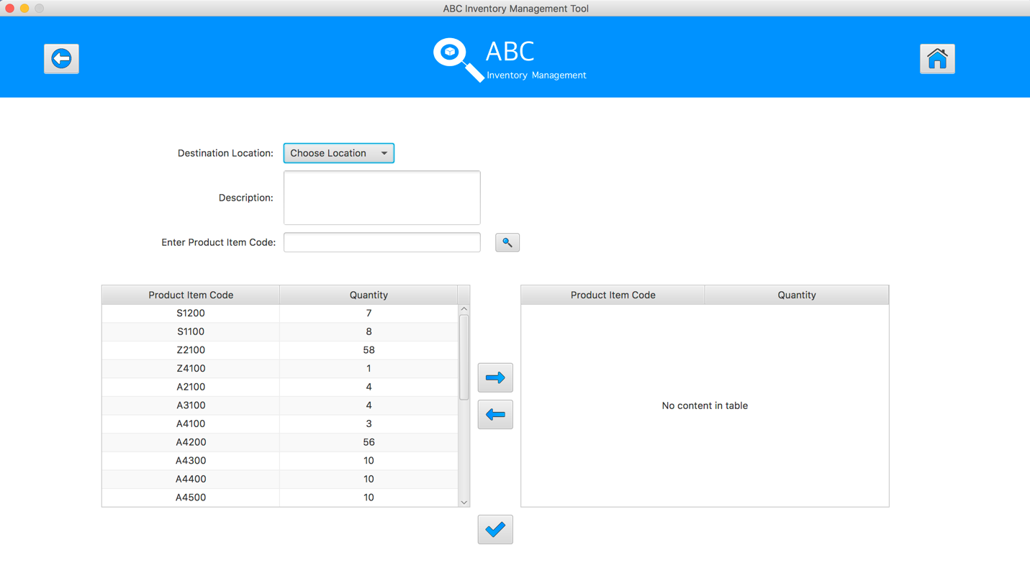

**Step 2**

Enter the description for this transfer

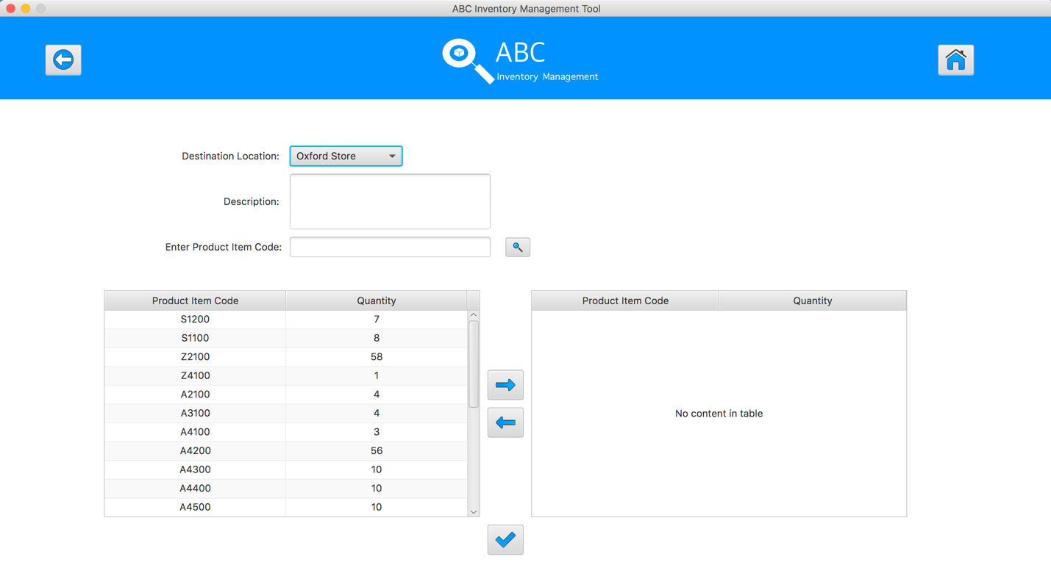

**Step 3**

Select the product item code in the table on the left

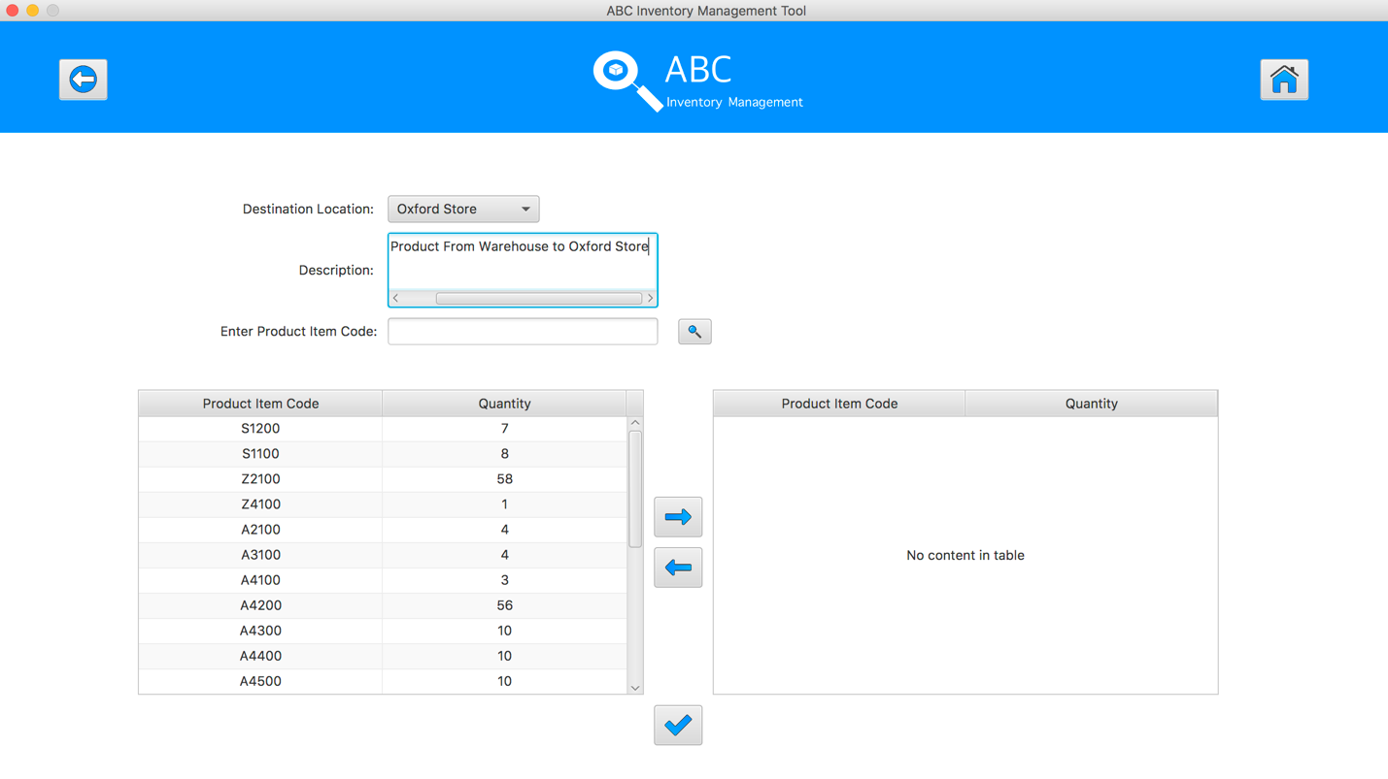

**Step 4**

Enter the product item code in search field and hit search button

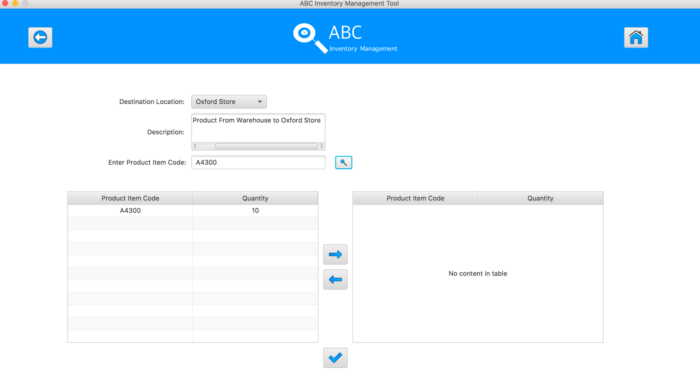

**Step 5**

Select the product item code in the table on the left

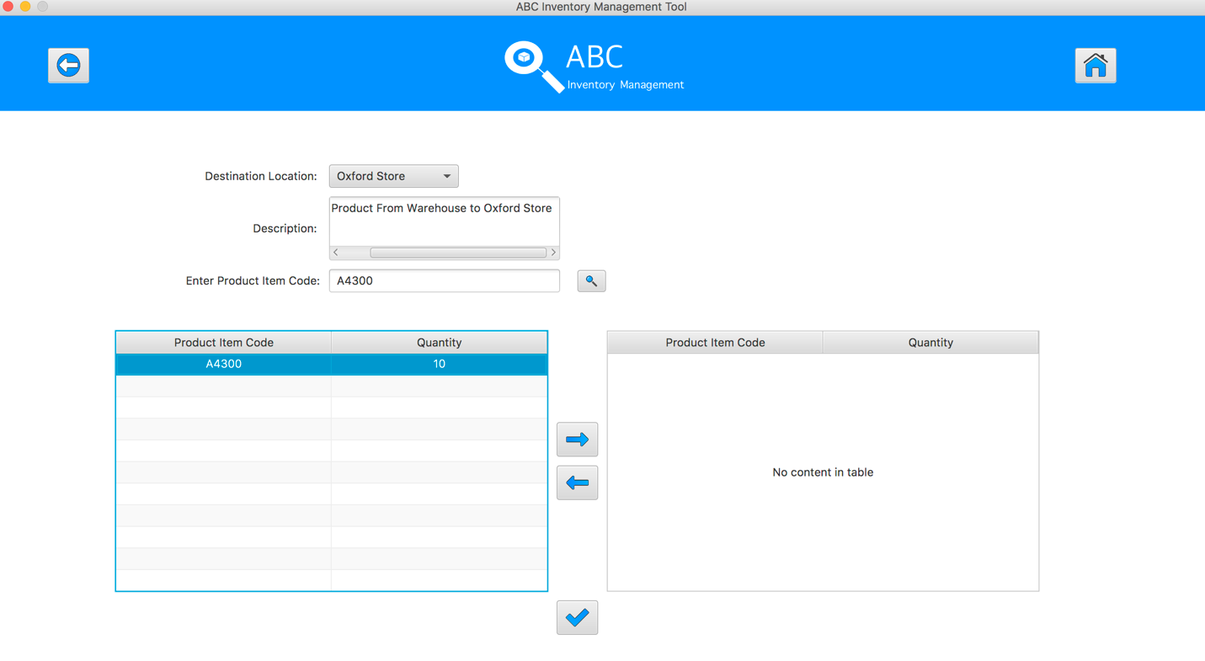

**Step 6**

Click on the “Add To Cart” Button

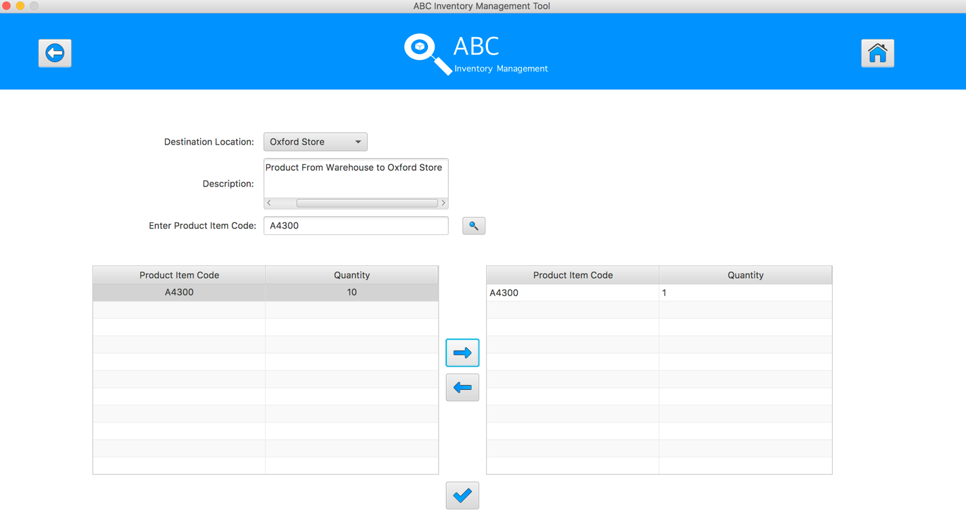

**Step 7**

Double click to the quantity cell in selected cart table

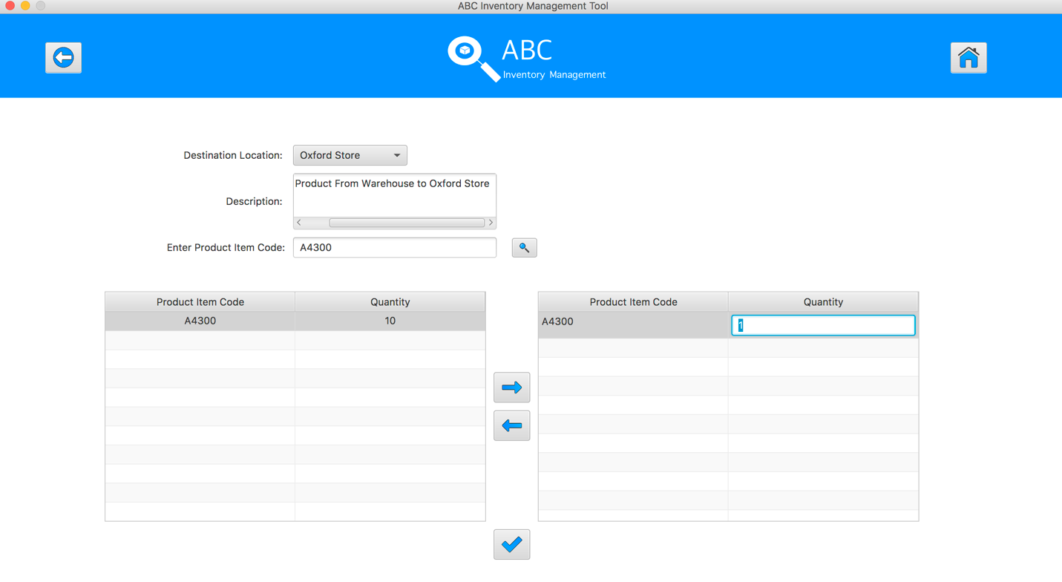

**Step 8**

Enter the desirable number

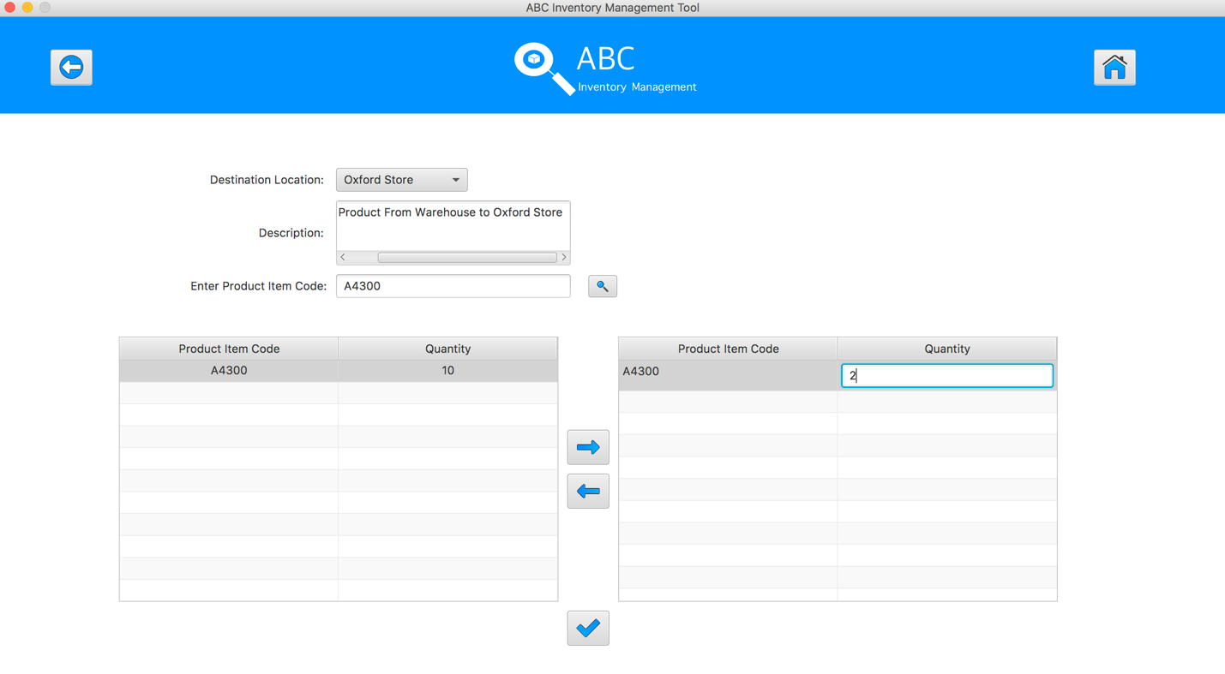

**Step 9**

Hit enter key to confirm this edited quantity

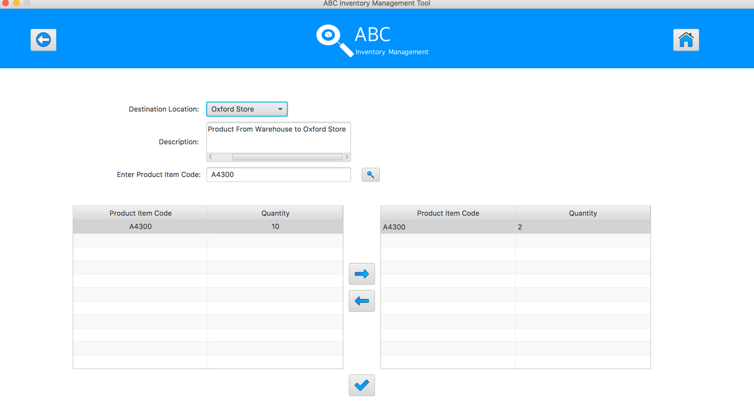

**Step 10**

Enter the product item code in search field and hit search button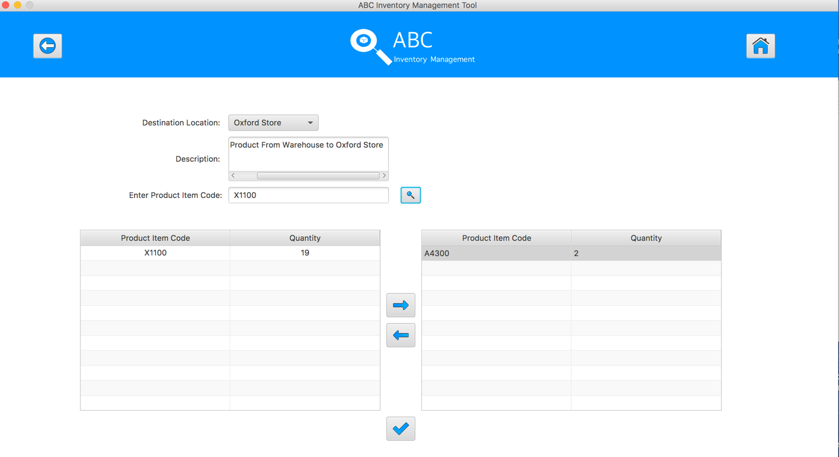

**Step 11**

Select the product item code in the table on the left

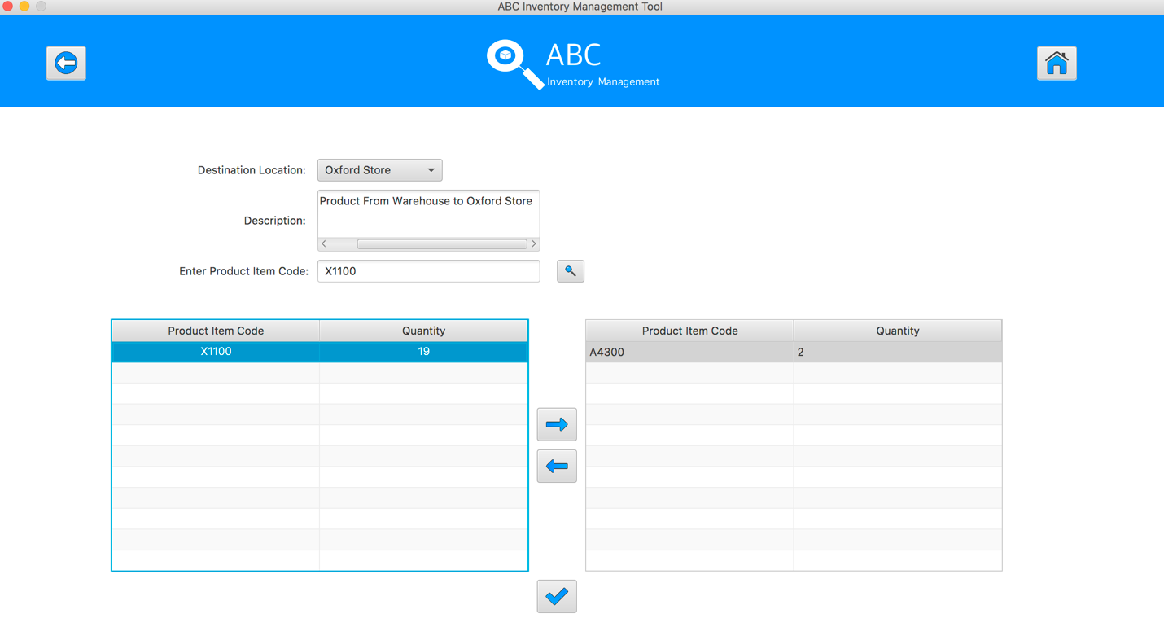

**Step 12**

Click on the “Add To Cart” Button

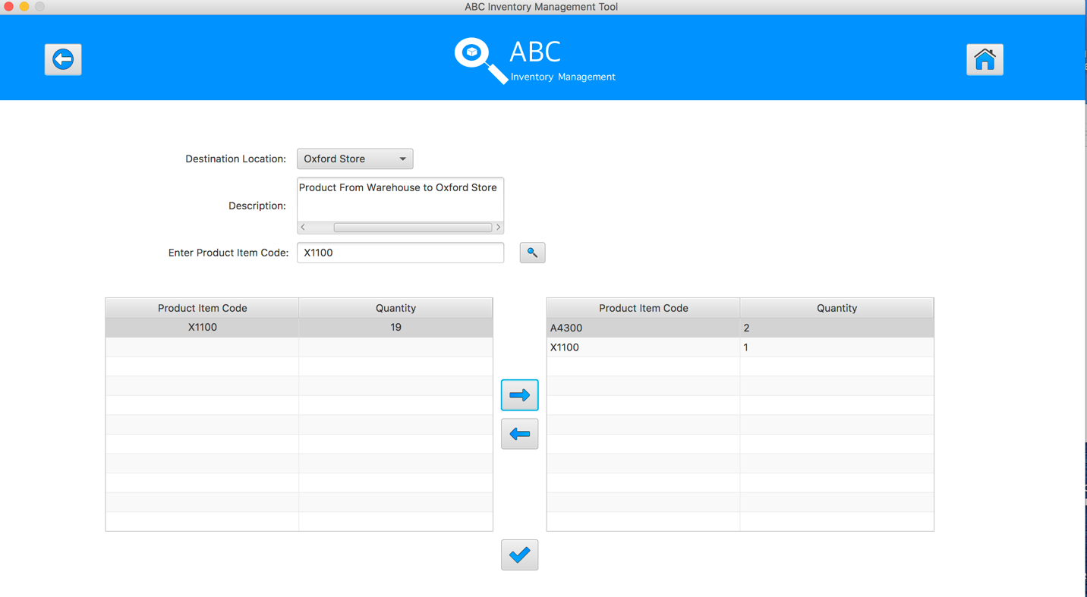

**Step 13**

Double click to the quantity cell in selected cart table

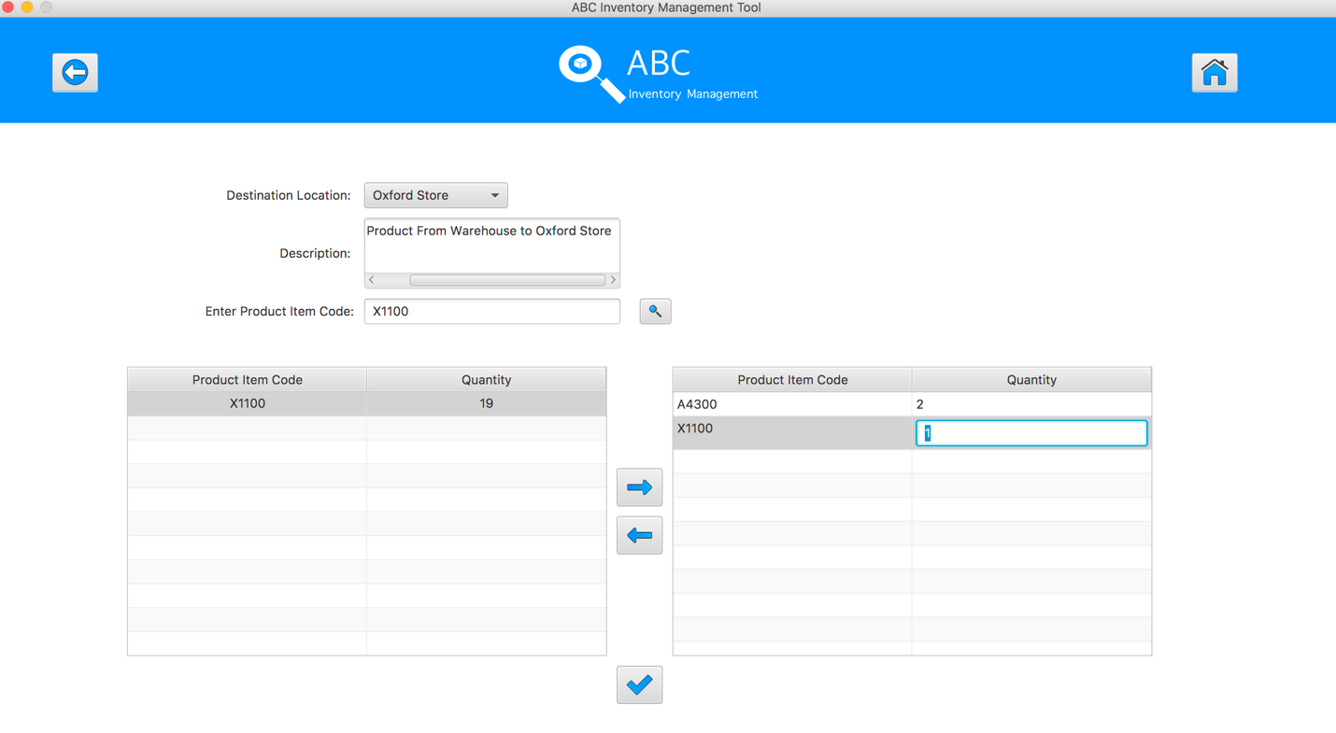

**Step 14**

Enter the desirable number

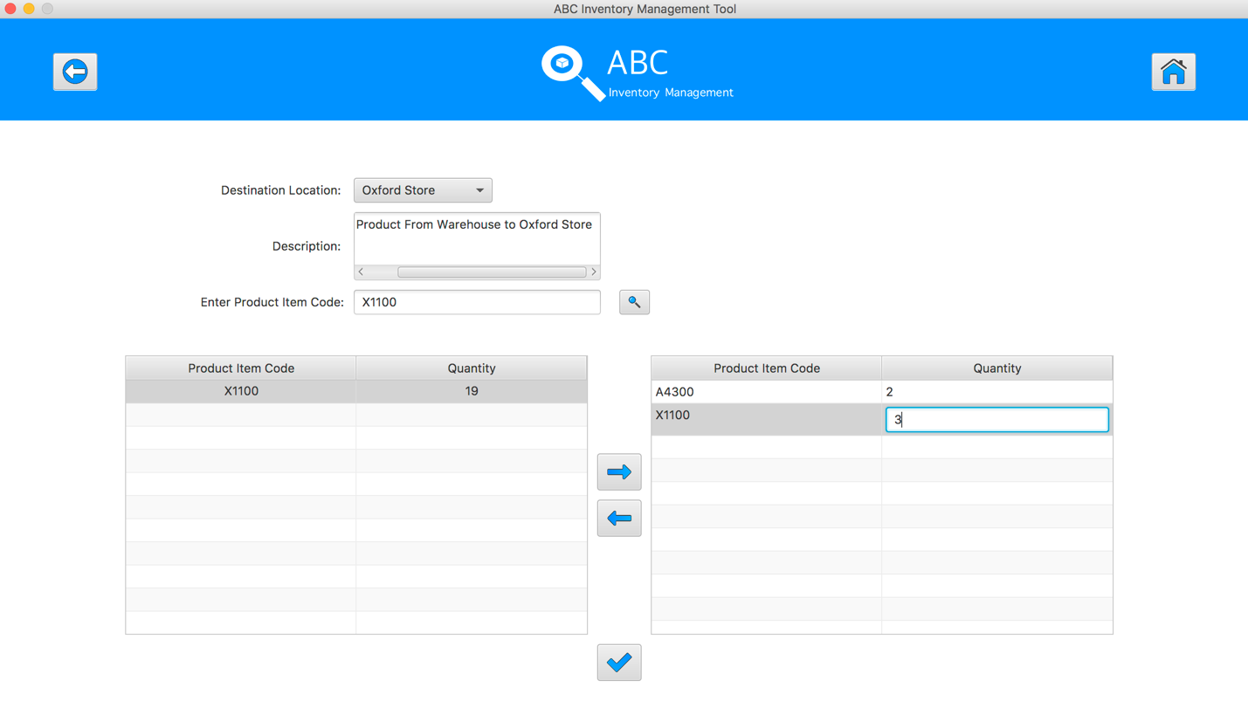

**Step 15**

Hit enter key to confirm this edited quantity

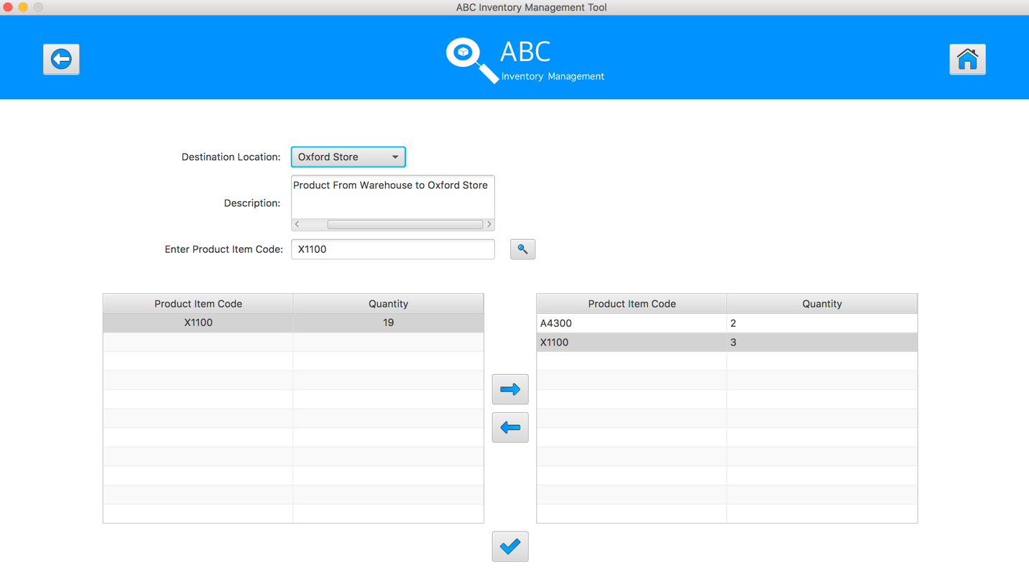

**Step 16**

Enter the product item code in search field and hit search button

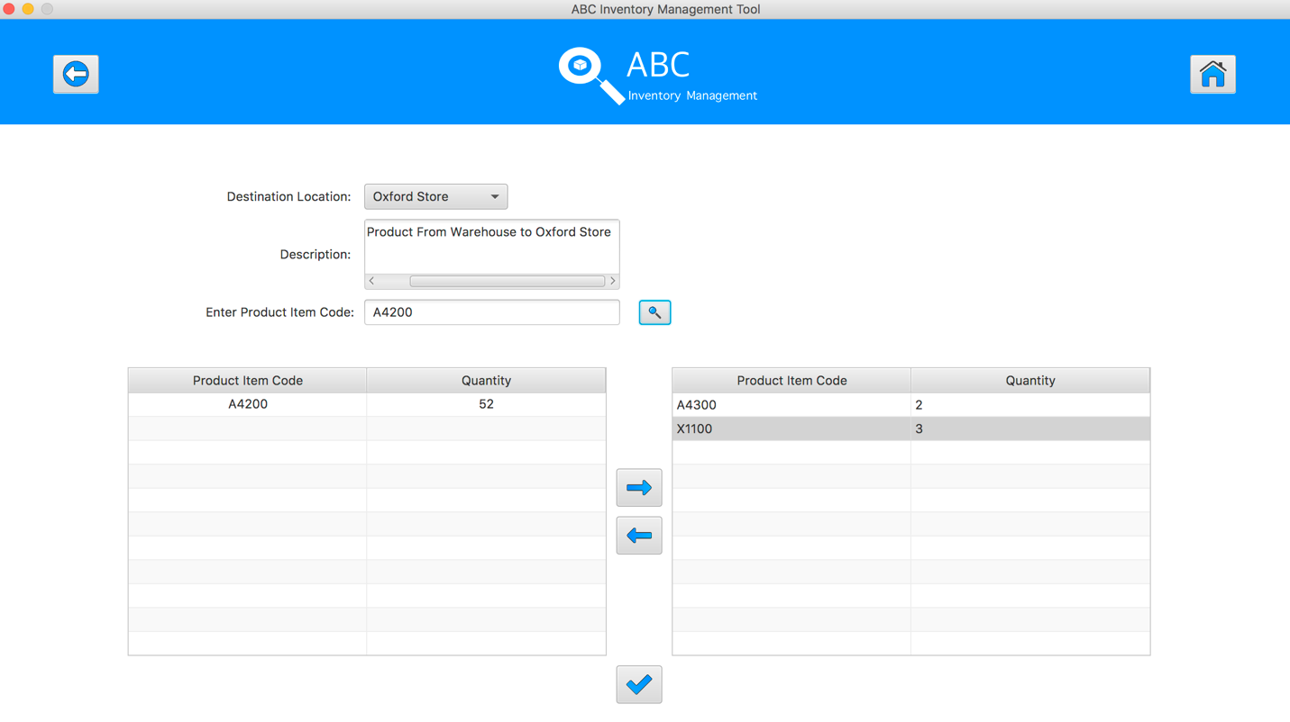

**Step 17**

Select the product item code in the table on the left

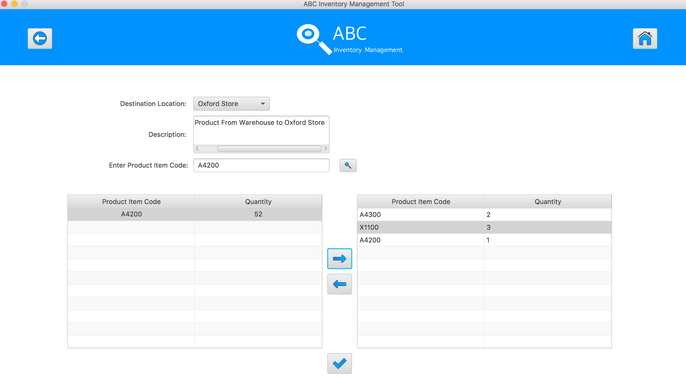

**Step 18**

Click on the “Add To Cart” Button



**Step 19**

Double click to the quantity cell in selected cart table

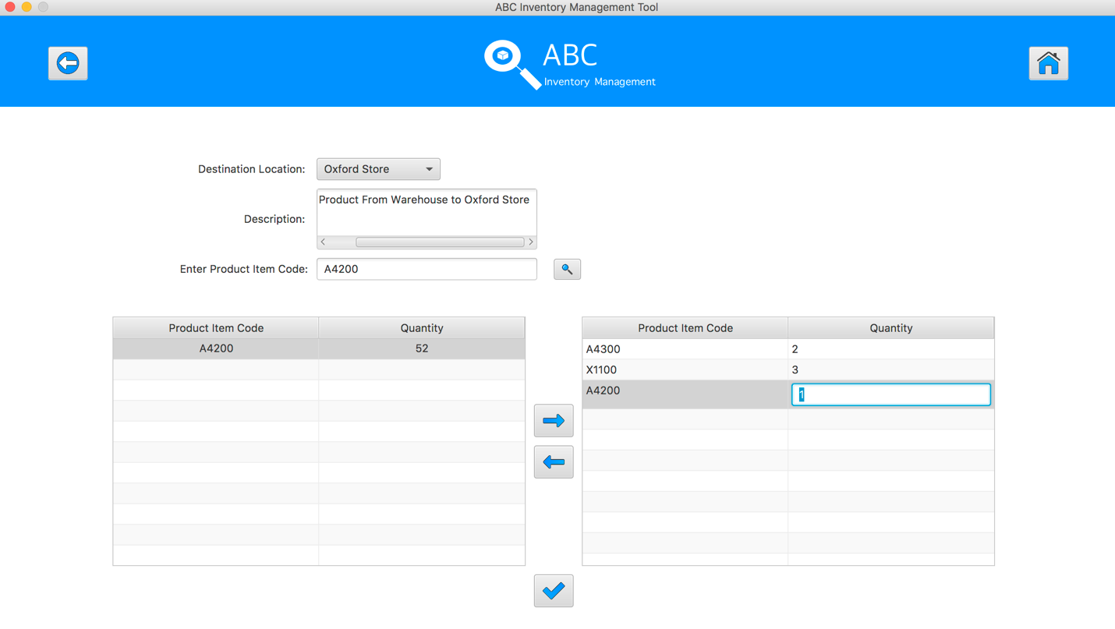

**Step 20**

Enter the desirable number

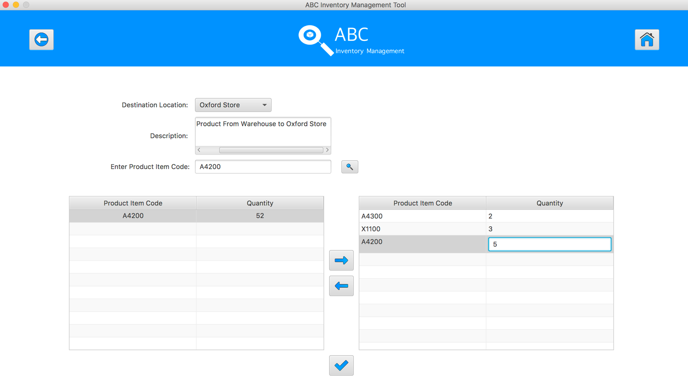

**Step 21**

Hit enter key to confirm this edited quantity

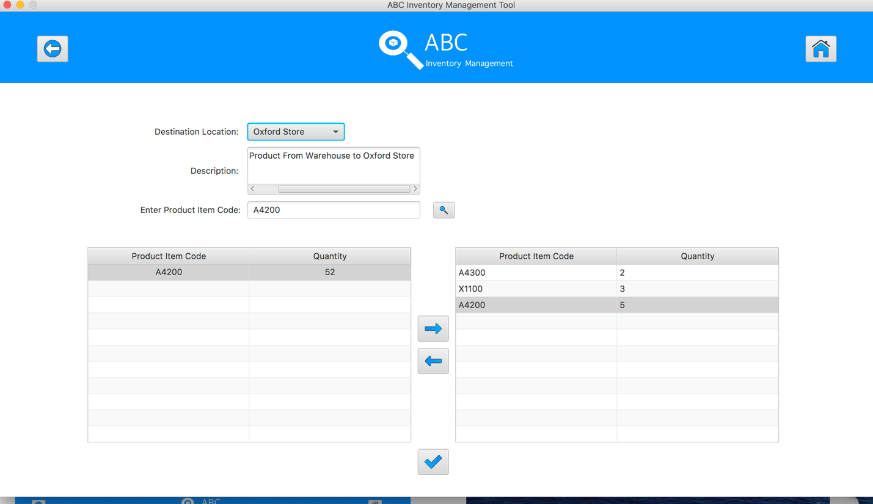

**Step 22**

After added the desirable items, hit the “Send Product” Button 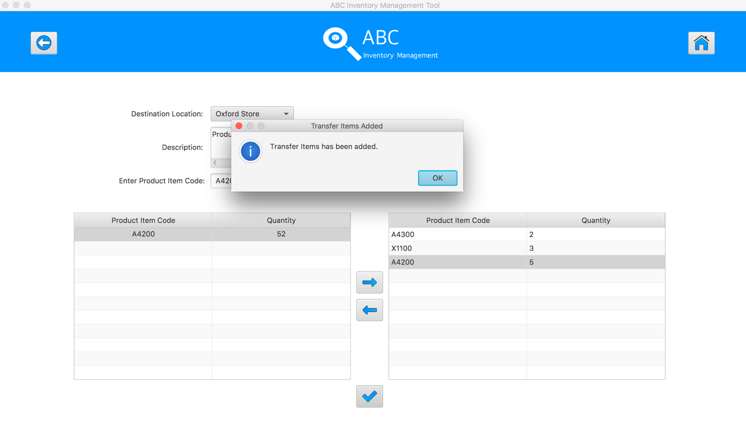

**Step 23**

Reset the interface for working with new transfer.

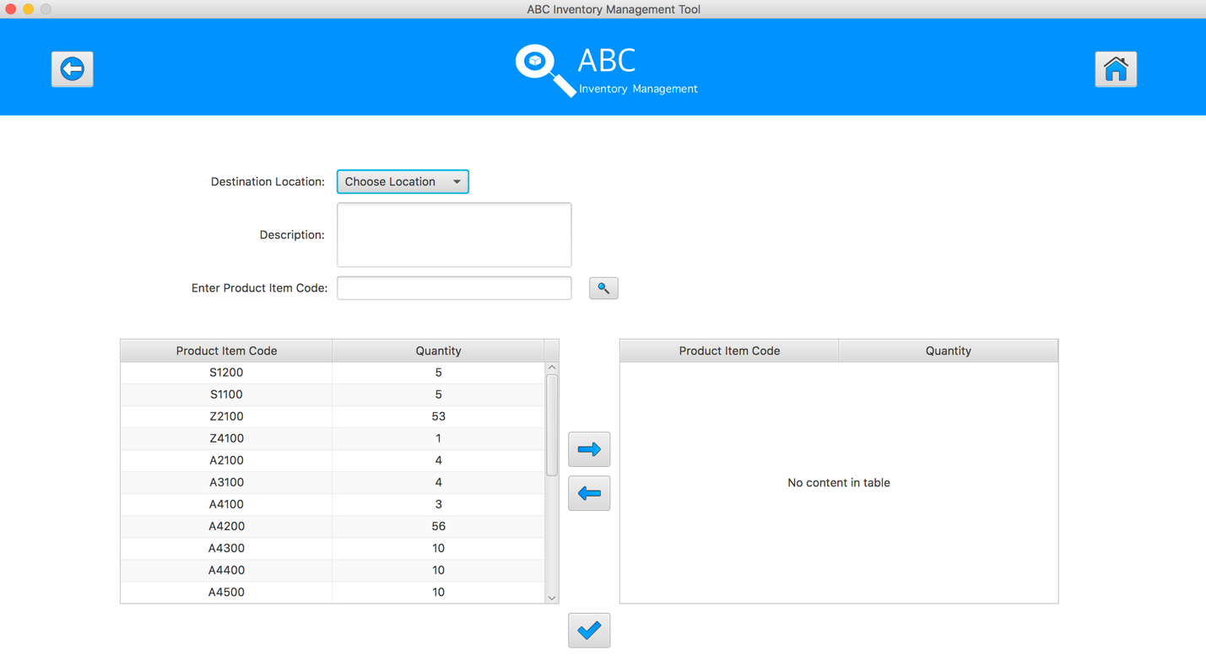

## Data Set 2

|  |  |  |  |
| --- | --- | --- | --- |
| **Test Data Table** | | | |
| **Destination Location** | Epping Store | | |
| **Description** | Send Product From Warehouse to Epping Store | | |
| **Product Item Code** | A4500 | X1200 | E1200 |
| **Quantity** | 3 | 2 | 2 |

# Result Screenshots

The screenshots of the result on each test step for each data set are given below:

**Step 1**

Select the destination location



**Step 2**

Enter the description for this transfer

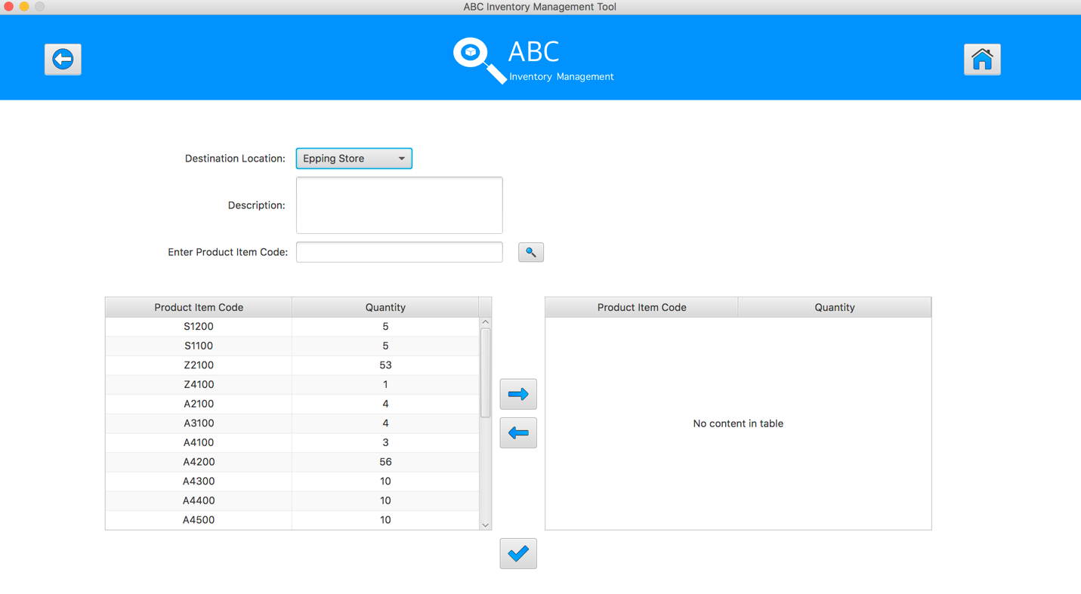

**Step 3**

Select the product item code in the table on the left

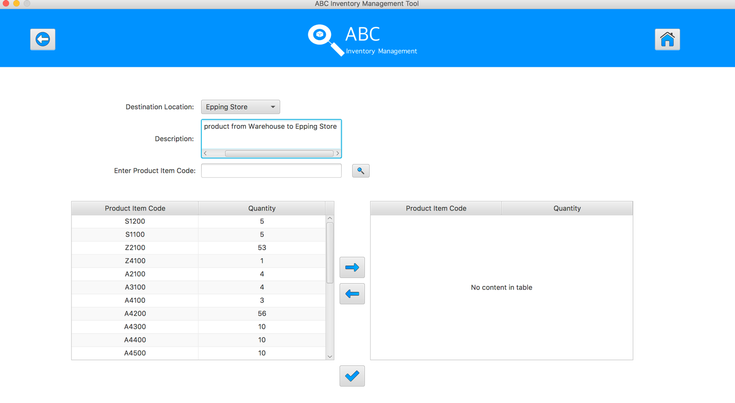

**Step 4**

Enter the product item code in search field and hit search button

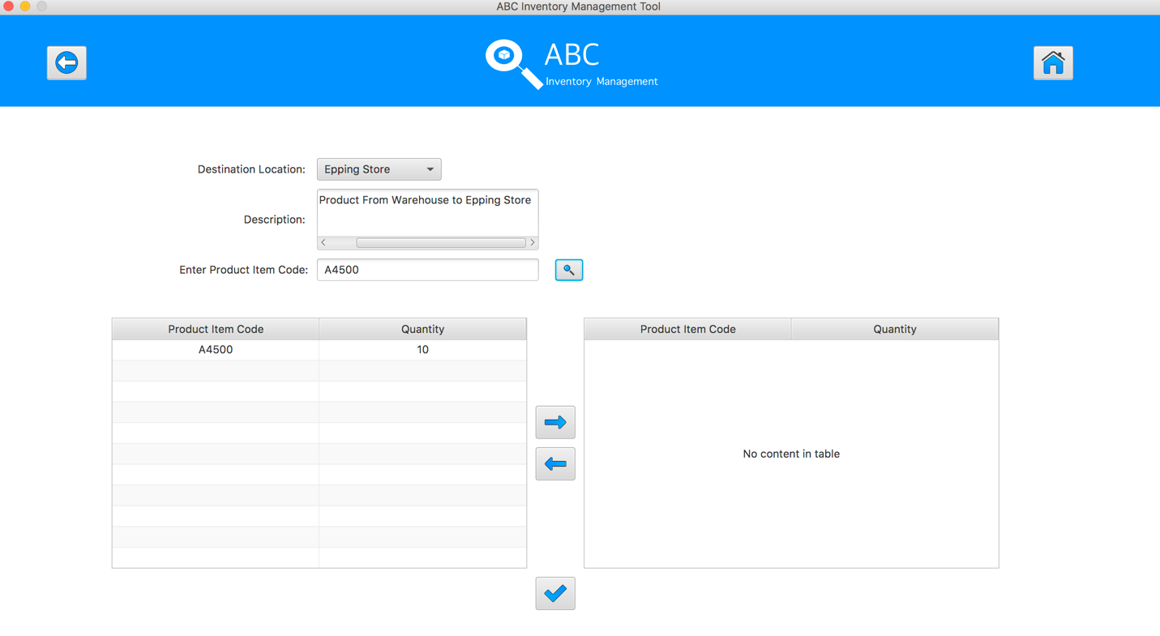

**Step 5**

Select the product item code in the table on the left

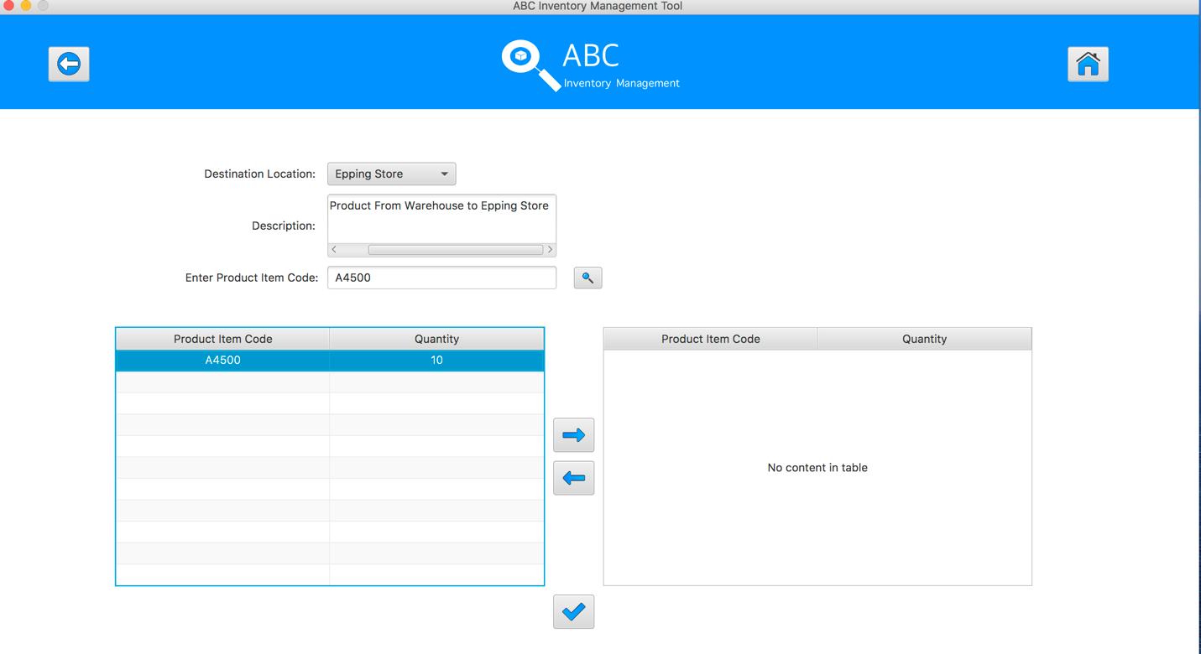

**Step 6**

Click on the “Add To Cart” Button

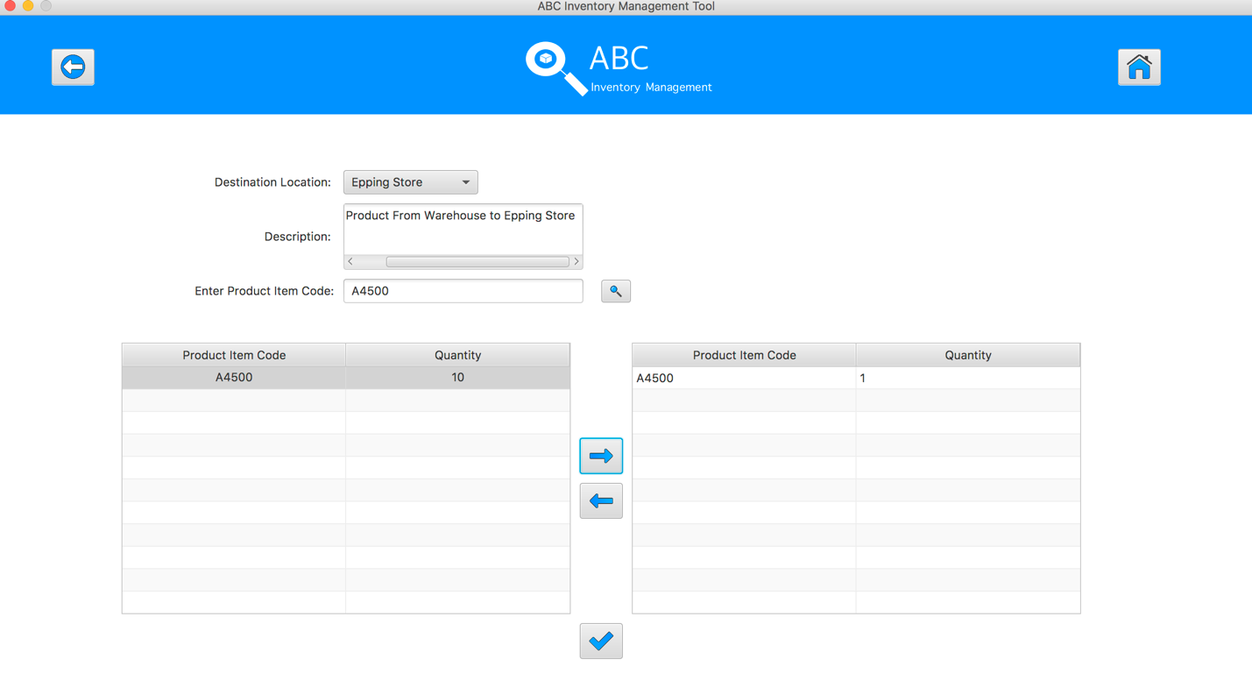

**Step 7**

Double click to the quantity cell in selected cart table

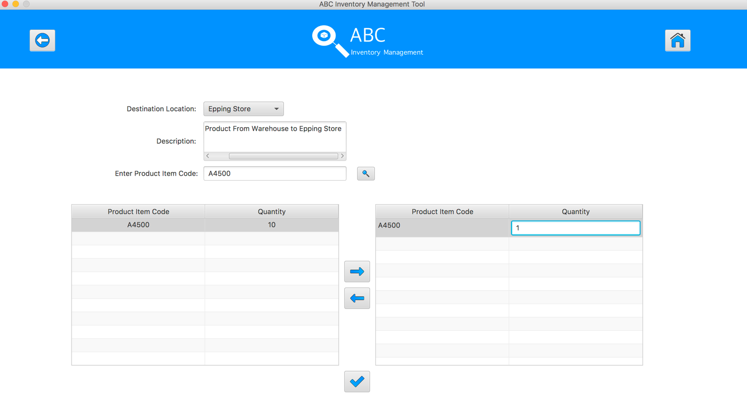

**Step 8**

Enter the desirable number

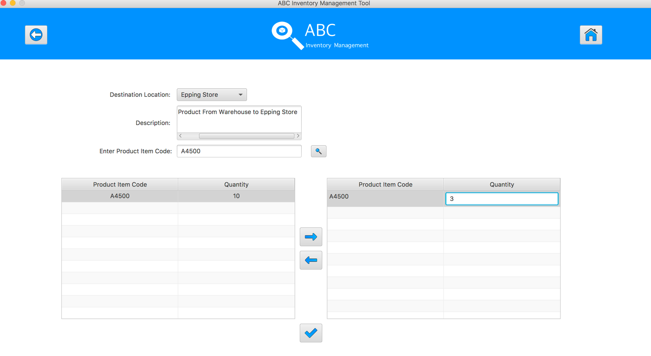

**Step 9**

Hit enter key to confirm this edited quantity

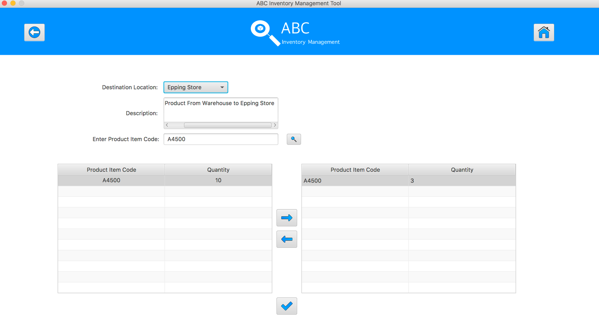

**Step 10**

Enter the product item code in search field and hit search button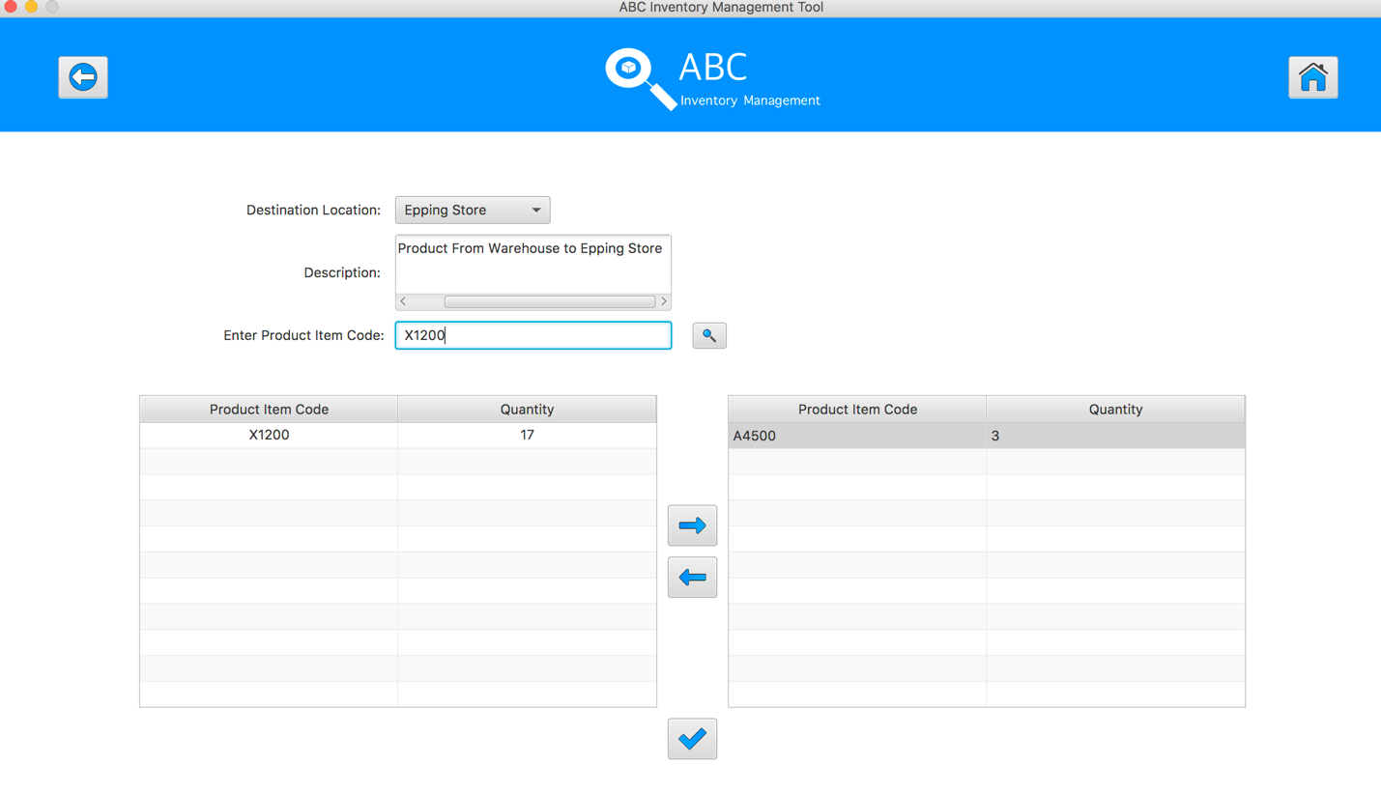

**Step 11**

Select the product item code in the table on the left

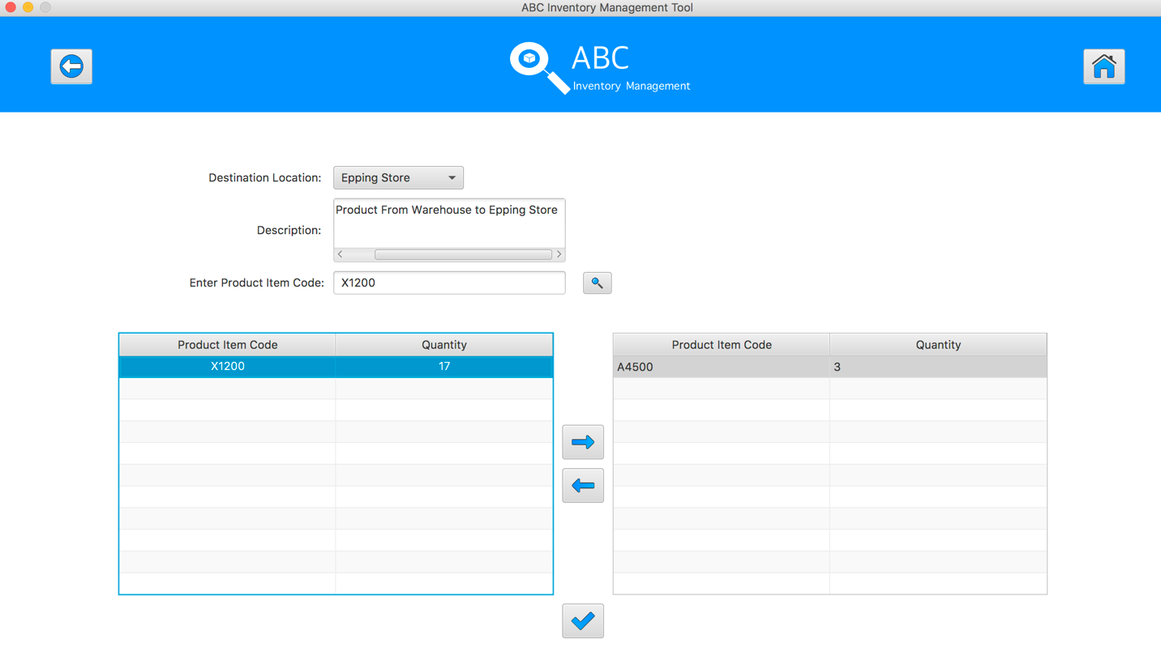

**Step 12**

Click on the “Add To Cart” Button

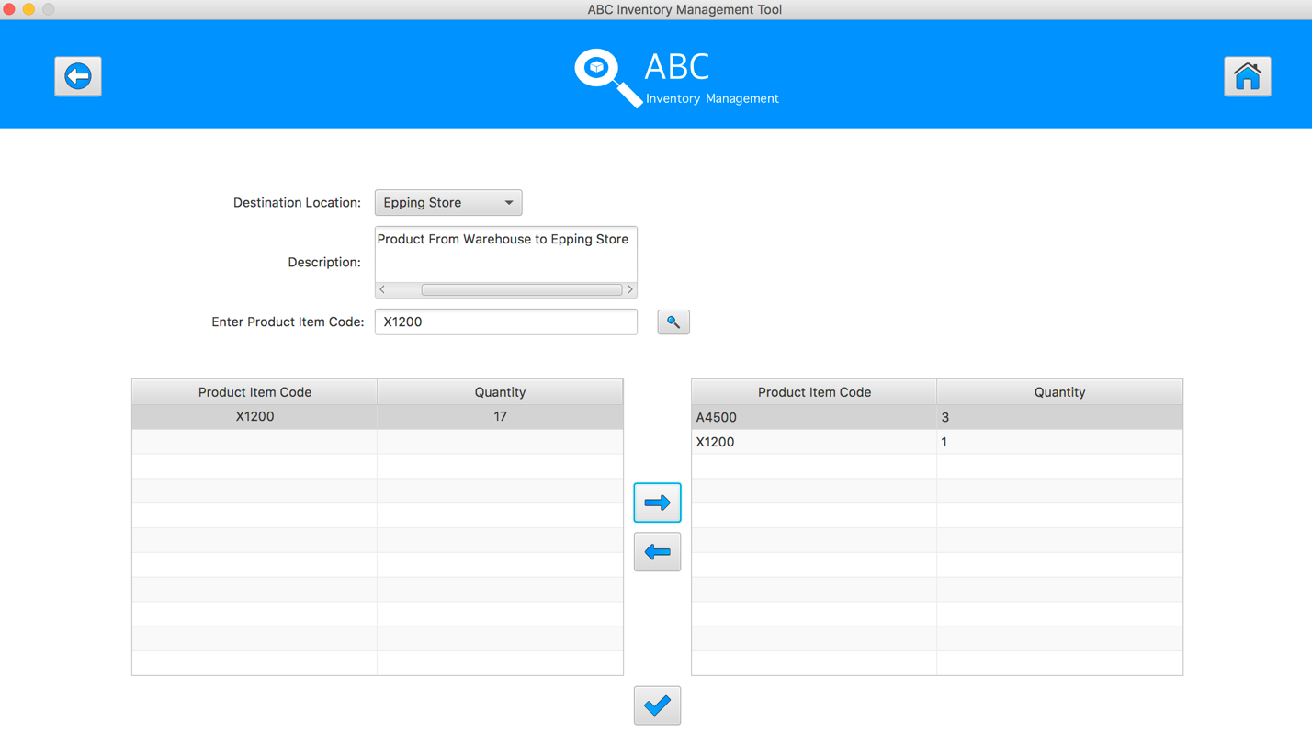

**Step 13**

Double click to the quantity cell in selected cart table

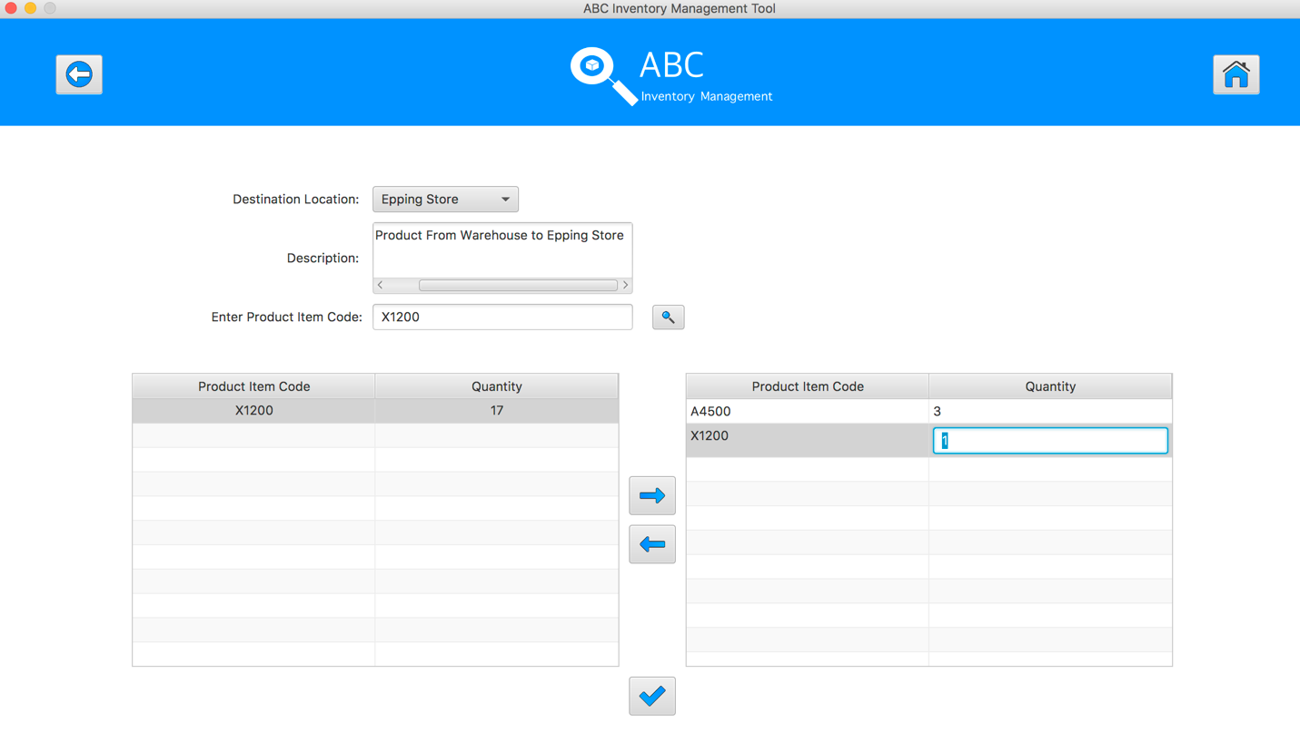

**Step 14**

Enter the desirable number

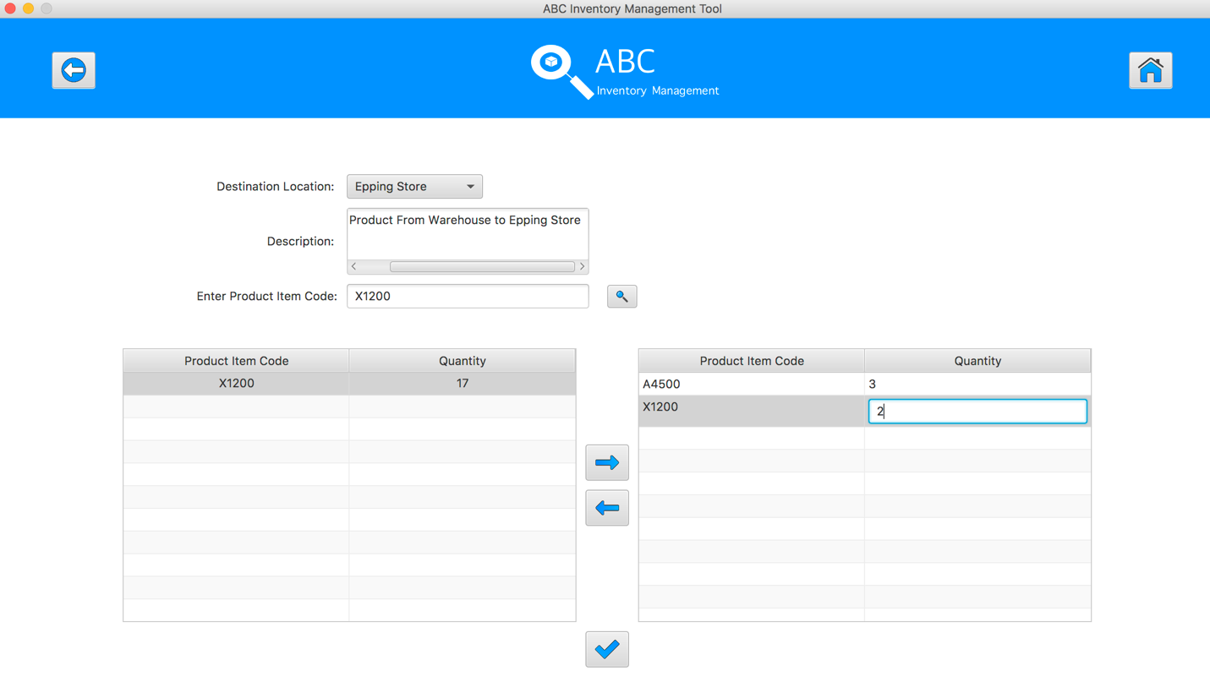

**Step 15**

Hit enter key to confirm this edited quantity

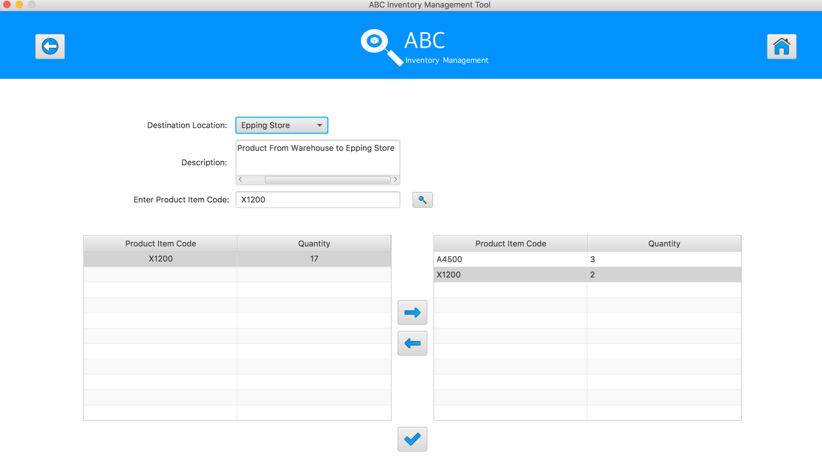

**Step 16**

Enter the product item code in search field and hit search button

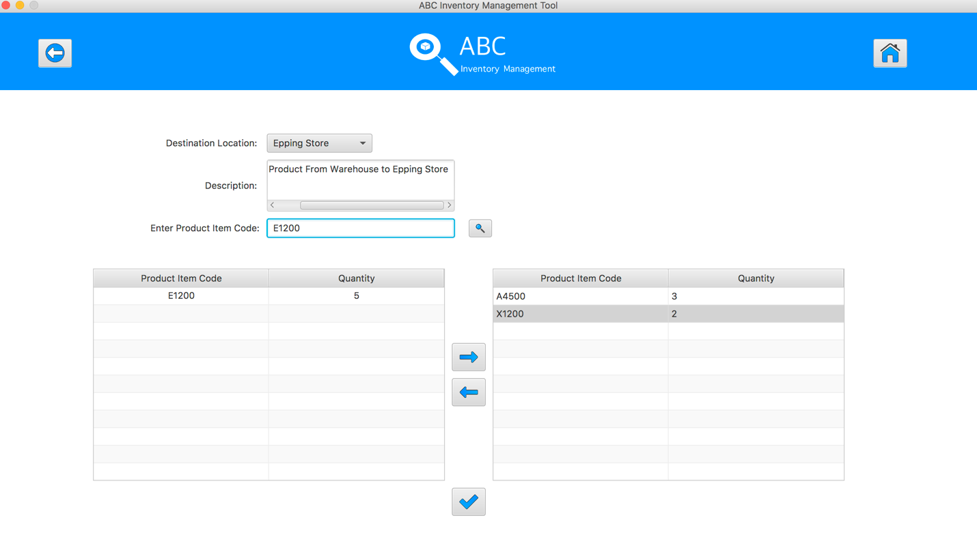

**Step 17**

Select the product item code in the table on the left

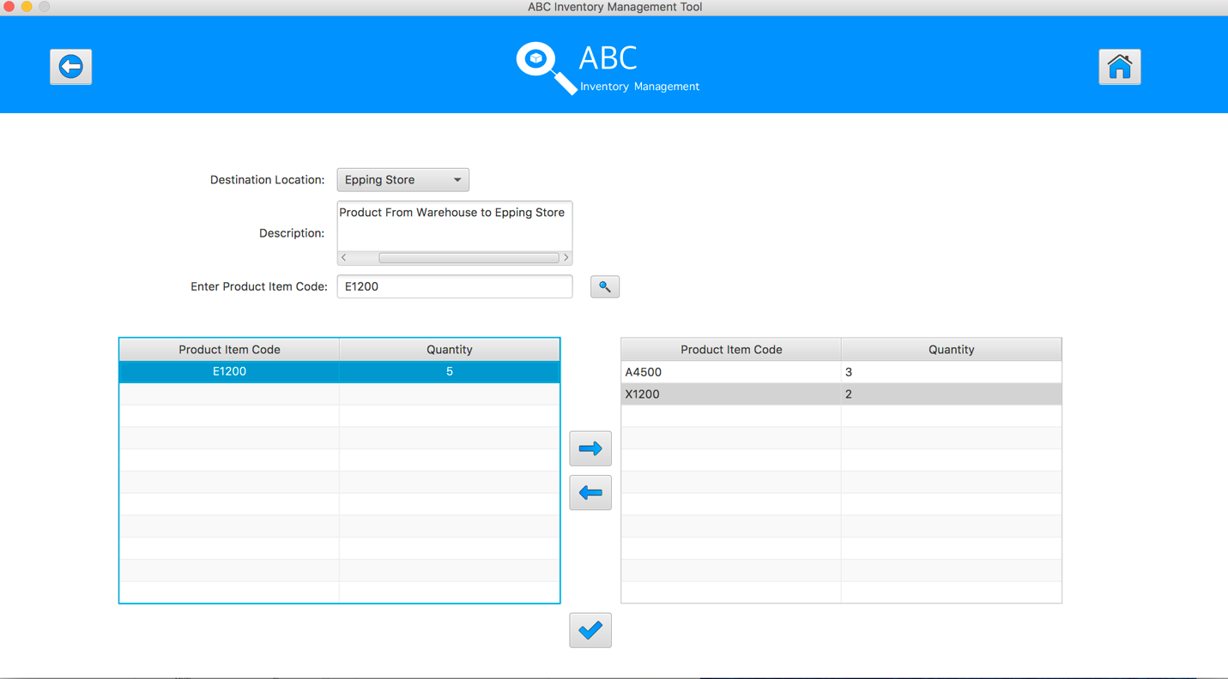

**Step 18**

Click on the “Add To Cart” Button

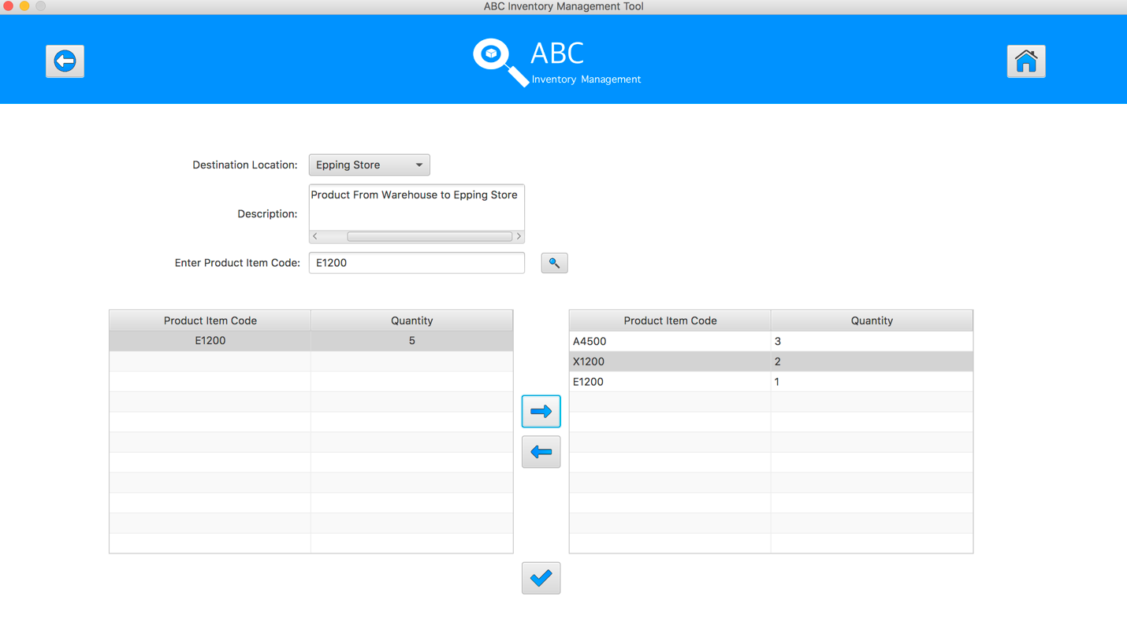

**Step 19**

Double click to the quantity cell in selected cart table

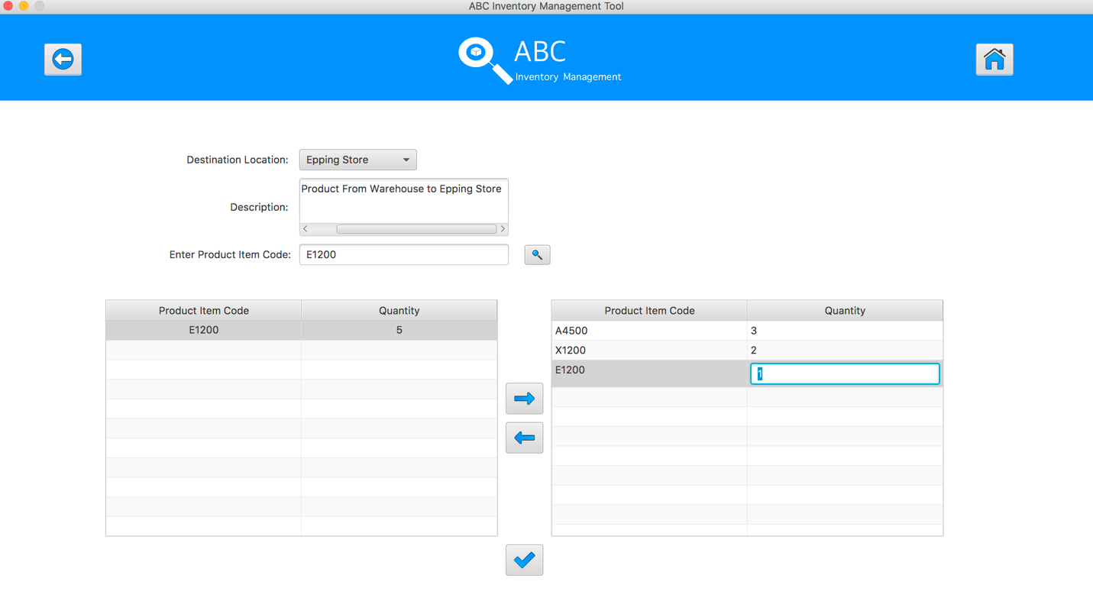

**Step 20**

Enter the desirable number

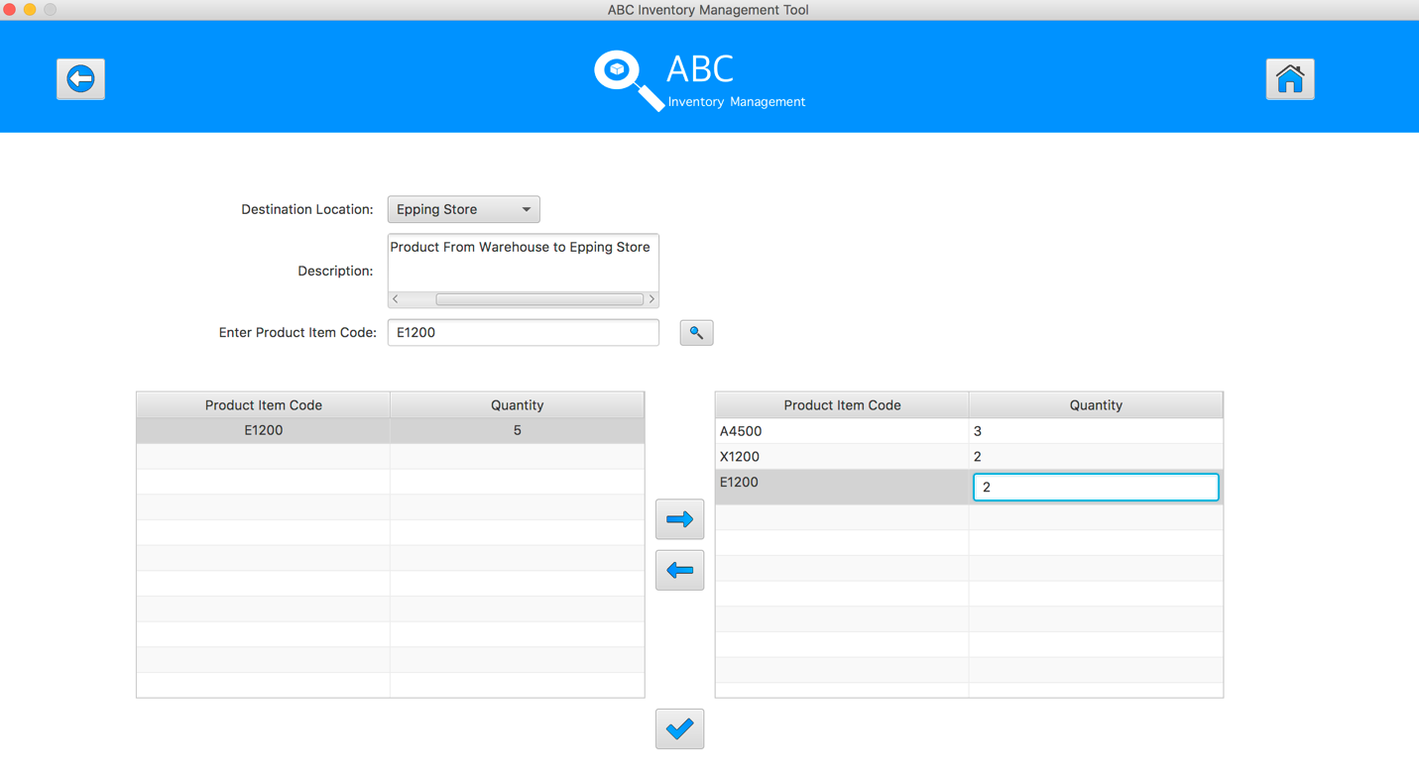

**Step 21**

Hit enter key to confirm this edited quantity

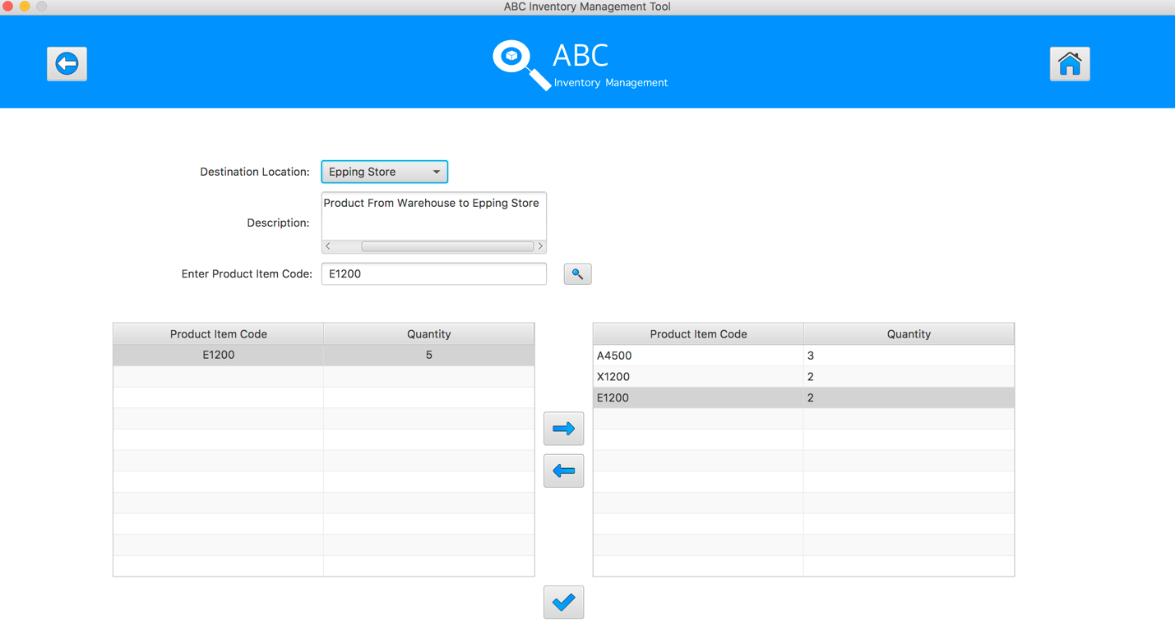

**Step 22**

After added the desirable items, hit the “Send Product” Button 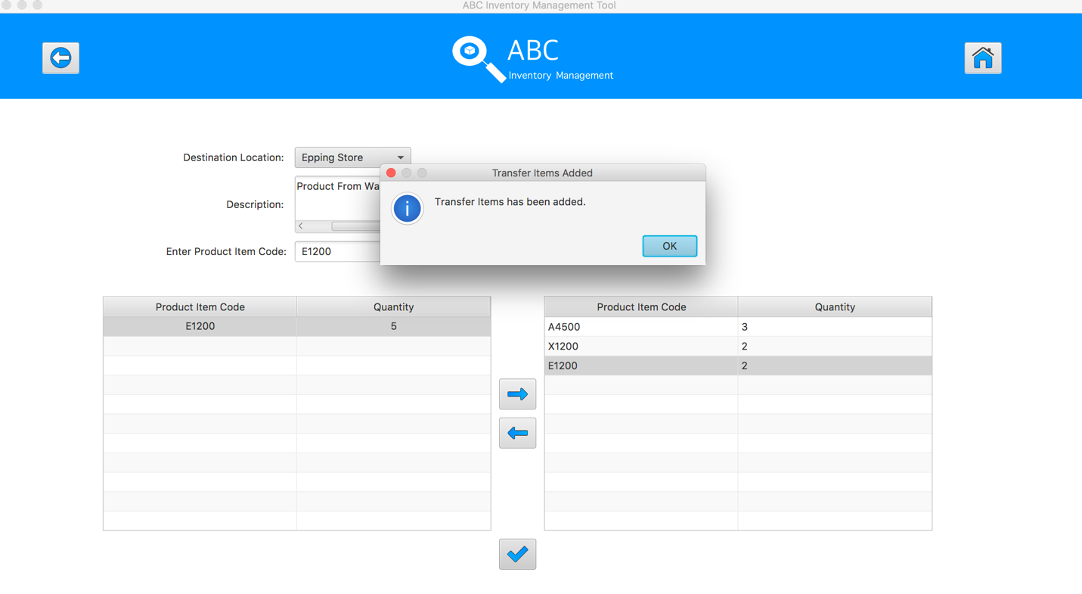

**Step 23**

Reset the interface for working with new transfer.

